
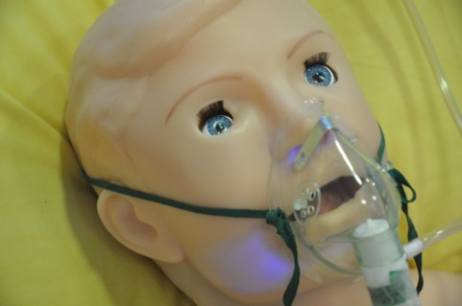
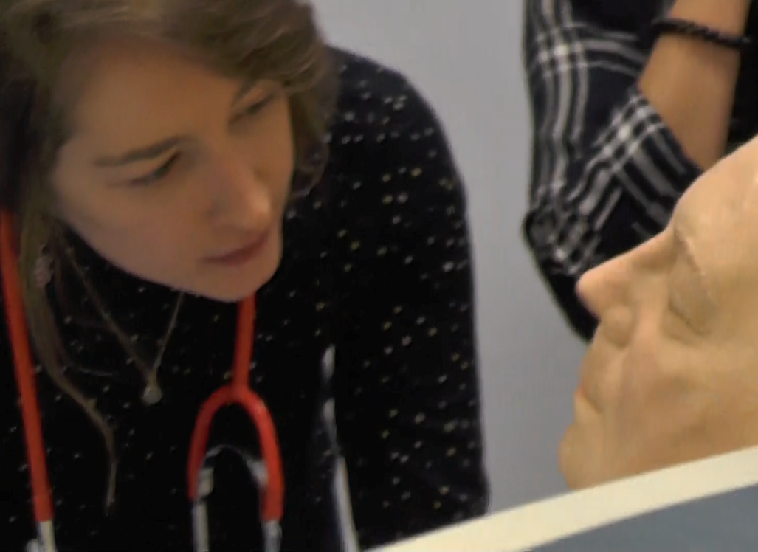
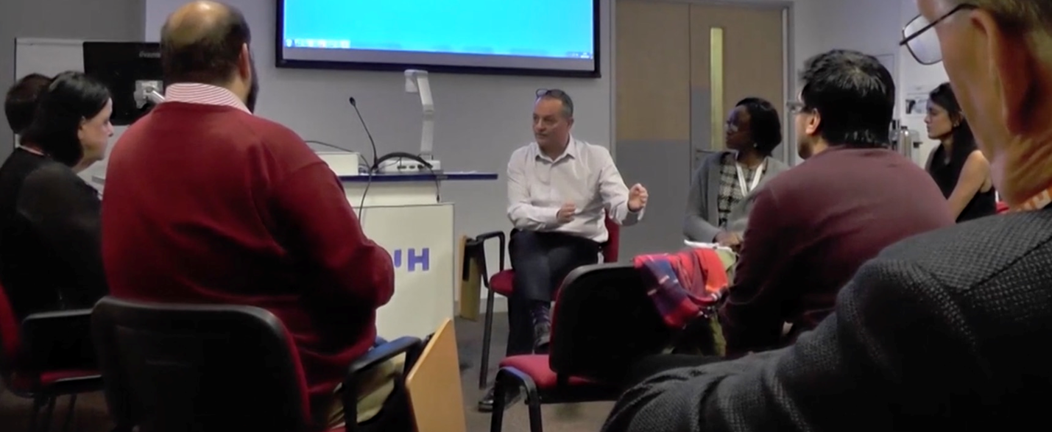
Postgraduate Medicine
Health and Medical Simulation – Design and Delivery
Code: 7LMS0163, Credits: 30, Level: M
The module aims to enable students to explore theories of learning relevant to the delivery of simulation based medical education. With an emphasis on evidence-based contemporary debriefing, students will be enabled to (further) develop these critical skills through real-time, practical facilitated simulation sessions within the excellent facilities at the University.

Students will be expected to design, deliver and evaluate a simulation session based on a scenario written according to the learning needs of their anticipated participants. This may involve neonatal, paediatric and adult subjects. Students will focus upon the use of structured debriefing to enhance both technical and non-technical skills learning. The utility of simulation in enhancing patient safety and its contribution to safer system design is also included in the curriculum.

Content
Includes the following:

- Explore & analyse educational approaches towards of learning relevant to simulation training.
- Developing and writing simulation scenarios
- Technical, environmental and psychological fidelity
- Creating educational safe spaces & psychological safety
- Evidence-based contemporary approaches to structured debriefing in simulation-based healthcare education
- Simulation, transfer to practice and the patient safety agenda
- Cost effectiveness and faculty development
- Simulation, and human factors/ergonomics
- Transformative simulation, i.e. using simulation in system / process design
- This module is complimented by 7LMS0164 ‘Medical Emergencies & Human Error’

Specific Entry Requirements
Employment or access to an appropriate area of practice. Full time students should have had relevant and recent work experience.

Dates Attendance at the University is required for two four-day study blocks.
Monday September 30th – Thursday October 3rd 2024
Monday November 25th – Thursday November 28th 2024

Study Route This module may be studied as a standalone module or as part of a longer academic award such as an MSc, Postgraduate Diploma or Postgraduate Certificate.

Fees Home fee status £TBC (subject to change)
Overseas fee status
http://www.herts.ac.uk/courses/msc-medical-and-healthcare-simulation

Venue F428, Clinical Simulation Centre, Ground Floor, Health Research Building, College Lane Campus.

Applications are very welcome!!
For further information on courses contact Ken Spearpoint MPhil, MSc, BSc (Hons), PGCertHE, RN, FHEA
Email k.g.spearpoint2@herts.ac.uk
To apply direct, email health@herts.ac.uk

