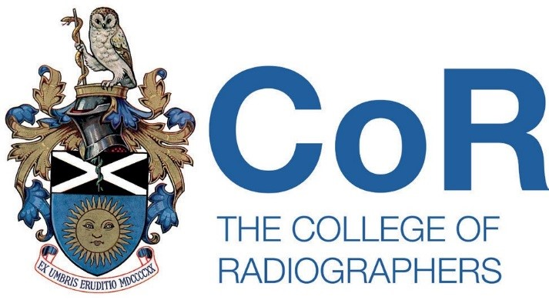

THE COLLEGE OF RADIOGRAPHERS

207 Providence Square, Mill Street
London SE1 2EW
Tel: 0207 740 7200

The College of Radiographers will use the course registration details supplied by you for purposes associated with education such as the administration of events, research, promotion and fundraising, processing award applications and maintaining education records. Our lawful basis for processing your information is to manage your registration and fulfil our legitimate interest as a professional body. We will share some of your information with the Society of Radiographers. We will retain all information you submit for the duration of your course registration and thereafter as verification of your participation. For detailed information about how we use your information please see http://www.sor.org/privacy-statement

APPLICATION FORM FOR REGISTRATION TO UNDERTAKE A
COURSE OF STUDY IN ADMINISTERING INTRAVENOUS INJECTIONS
INCOMPLETE OR ILLEGIABLE FORMS WILL BE RETURNED PRIOR TO REGISTRATION

PLEASE USE BLOCK CAPITALS AND BLACK PEN

1. SURNAME: (Mr/Mrs/Ms/Miss)
FORENAMES:
2. HOME ADDRESS:

POSTCODE:
3. DATE OF BIRTH:
4 SoR MEMBERSHIP NUMBER:
5. REGISTRATION NUMBER: (HCPC OR EQUIVALENT)
6 QUALIFICATIONS:
7. JOB TITLE:
8 SIGNATURE OF APPLICANT:

TO BE COMPLETED BY EDUCATION CENTRE
9. I certify that ……………………………………………………………………………………. has been accepted to commence a course of study in administering intravenous injections on ……………/………………/…………….at (education centre) .…………………………………………………………………………………………………
SIGNATURE : …………………………………………..……………. DATE: ………………………..
(signed on behalf of education centre)

NOTES

- Please contact The Society of Radiographers to confirm your membership number: membership@sor.org / 020 7740 7200 option 1
- On registration candidates will be issued with a copy of the Course of study for Certificate of Competence in Administering Intravenous Injections and Record of Clinical Experience and an IV registration number.

